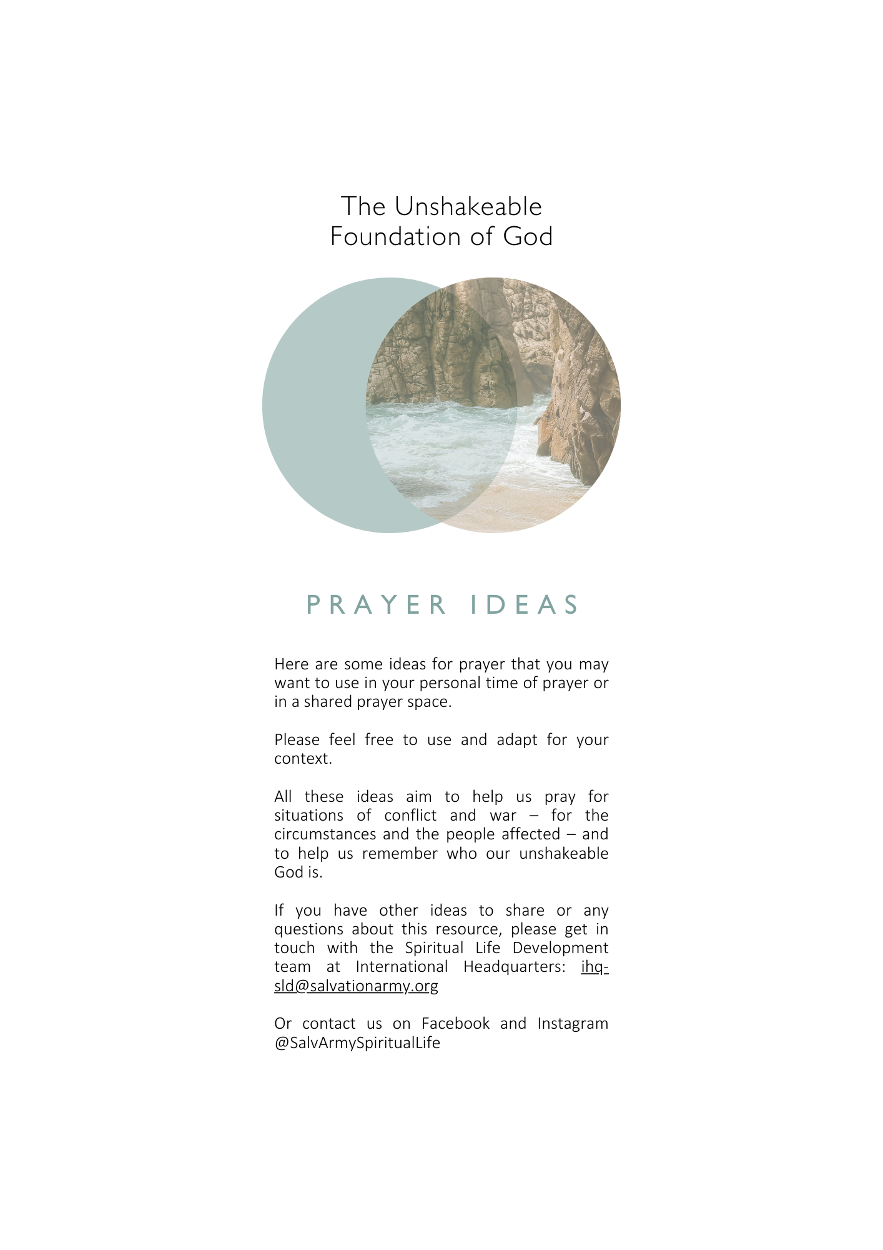
Here are some ideas for prayer that you may want to use in your personal time of prayer or in a shared prayer space.
Please feel free to use and adapt for your context.
All these ideas aim to help us pray for situations of conflict and war – for the circumstances and the people affected – and to help us remember who our unshakeable God is.
If you have other ideas to share or any questions about this resource, please get in touch with the Spiritual Life Development team at International Headquarters: ihq-sld@salvationarmy.org
Or contact us on Facebook and Instagram @SalvArmySpiritualLife
Psalm 46
You are invited to spend time in scripture.

Read Psalm 46 in its entirety. Read it slowly and deliberately. Ask God to direct your attention or reveal something new to you in your reading of this Psalm today.

You may want to record what God is revealing to you through his word.

You will need:
- Bibles or a printout of Psalm 46. You may want to have multiple translations available.
- Art materials, pens, paints etc. for those who would like to respond creatively to their reading.

If you are creating a prayer space for others, here are some instructions to print:

Psalm 46

You are invited to spend time in scripture.

Read Psalm 46 in its entirety.

Read it slowly and deliberately.

Ask God to direct your attention or reveal something new to you in your reading of this Psalm today.

You may want to record what God is revealing to you through his word.
Psalm 46

For the director of music. Of the Sons of Korah. According to alamoth. A song.

1 God is our refuge and strength,
an ever-present help in trouble.
2 Therefore we will not fear, though the earth give way
and the mountains fall into the heart of the sea,
3 though its waters roar and foam
and the mountains quake with their surging.

4 There is a river whose streams make glad the city of God,
the holy place where the Most High dwells.

5 God is within her, she will not fall;
God will help her at break of day.

6 Nations are in uproar, kingdoms fall;
he lifts his voice, the earth melts.

7 The Lord Almighty is with us;
the God of Jacob is our fortress.

8 Come and see what the Lord has done,
the desolations he has brought on the earth.

9 He makes wars cease
to the ends of the earth.
He breaks the bow and shatters the spear;
he burns the shields with fire.

10 He says, ‘Be still, and know that I am God;
I will be exalted among the nations,
I will be exalted in the earth.’

11 The Lord Almighty is with us;
the God of Jacob is our fortress.

News Headlines
There are so many people experiencing conflict in our local communities and around the world. Spend some time looking through the newspapers, magazines and articles before you. As you read, you might like to ask yourself these questions:

What’s happening?
Where?
Who is affected?
Who are the key leaders and who will be responding?
What are the needs right now?

Cut out a headline or article that captures your attention and paste it on the poster. Write your thoughts next to them.

Offer a prayer for the specific news headline and the people it concerns.

You will need:
- a collection of local, national and international newspapers, magazines or printed news articles.
- scissors.
- glue.
- pens.
- poster paper.

If you are creating a prayer space for others, here are some instructions to print:

News Headlines

There are so many people experiencing conflict in our local communities and around the world. Spend some time looking through the newspapers, magazines and articles before you. As you read, you might like to ask yourself these questions:

What’s happening?
Where?
Who is affected?
Who are the key leaders and who will be responding?
What are the needs right now?

Cut out a headline or article that captures your attention and paste it on the poster. Write your thoughts next to them.

Offer a prayer for the specific news headline and the people it concerns.

Playlist
We have curated a playlist of songs that affirm who God is, regardless of our circumstances. You may want to use this playlist or create your own to play aloud or listen to in this prayer space.

You can find the playlist here: sar.my/spirituallife

If you are creating a prayer space for others, here are some instructions to print:

We have curated a playlist of songs that affirm who God is, regardless of our circumstances.

You may want to use this playlist or create your own to listen as you pray.

You can find the playlist here: sar.my/spirituallife

The unshakable God is my refuge.

Rest In the Shadow of the Almighty.

‘Whoever dwells in the shelter of the Most High
will rest in the shadow of the Almighty.
I will say of the Lord, “He is my refuge and my fortress,
my God, in whom I trust.”’ (Psalm 91:1-2)

Look at the map before you. Where on the map is the Lord drawing your attention?

Hold the light up to the map. Move your hand in front of the light to create a shadow on the map over those areas you would like to pray for.

Pray for those people to rest in the shadow of the Almighty.

You will need:
- a map of the world or your local area.
- a torch or source of light.

If you are creating a prayer space for others, here are some instructions to print:

Rest In the Shadow of the Almighty.

‘Whoever dwells in the shelter of the Most High
will rest in the shadow of the Almighty.
I will say of the Lord, “He is my refuge and my fortress,
my God, in whom I trust.”’ (Psalm 91:1-2)

Look at the map before you.

Where on the map is the Lord drawing your attention?

Hold the light up to the map.

Move your hand in front of the light to create a shadow on the map over those areas you would like to pray for.

Pray for those people to rest in the shadow of the Almighty.

‘Be Still and Know That I Am God’

Create a quiet and comfortable place to sit with God in the quiet.

You can create a comfortable seating area with cushions or blankets, or you may want to use some sheets or a tent to build a physical shelter free from distraction.

Get comfortable sitting, lying or standing in this quiet space and take time to rest in the presence of God.

Be still.

Be still and know that God is God.

What do you need to stop striving for and instead rely on the strength of God?

You will need:
- comfortable chairs, cushions, blankets.

If you are creating a prayer space for others, here are some instructions to print:

‘Be Still and Know That I Am God’

You are in the presence of God.

Find a comfortable posture to rest in this quiet place.

Be still.

Be still know that God is God.

Is there something you need to stop striving for?

What do you need to surrender and instead rely on the strength of God?

Let God be God.

Stay here as long as you need.

The Unshakable God gives me courage.

At the Foot of the Cross

Sit at the foot of the cross.

Hurt, bitterness, betrayal, anger, resentment – what can you leave here?

Leave anything you need to here. You may want to write it down, scrunch it up and physically leave it at the foot of the cross.

What do you need to confess? Ask God for forgiveness.

Who do you need to forgive?

What next steps do you need to take to restore a broken relationship?

You will need:
- cross.
- pens.
- card/paper.

If you are creating a prayer space for others, here are some instructions to print:

Sit at the foot of the cross.

Hurt, bitterness, betrayal, anger, resentment – what can you leave here?

Leave anything you need to here. You may want to write it down, scrunch it up and physically leave it at the foot of the cross.

What do you need to confess? Ask God for forgiveness.

Who do you need to forgive?

What next steps do you need to take to restore a broken relationship?

Commitment to Action

Change starts with us.

Write down a specific action you will take to contribute to peace (in my personal relationships, educating myself, educating others, committing to prayer) and place it on the commitment board.

Commit to resolving differences and conflicts at home, work and perhaps even at church, peacefully through dialogue and compassion. Commit to treating others with respect, practicing empathy and living in harmony with others. Commit to praying regularly for the world and areas of conflict.

You will need:
- pens.
- commitment card.
- a board/wall to display cards.

If you are creating a prayer space for others, here are some instructions to print:

Change starts with us.

Write down a specific action you will take to contribute to peace (in my personal relationships, educating myself, educating others, committing to prayer) and place it on the commitment board.

Commit to resolving differences and conflicts at home, work and perhaps even at church peacefully through dialogue and compassion.

Commit to treating others with respect, practicing empathy and living in harmony with others.

Commit to praying regularly for the world and for areas of conflict.

I commit to…

Letters of Hope

When we hear trusted voices, voices of those we know and love, declaring the goodness and faithfulness of God, we can find hope and strength in their confidence and love. Reflect on how simple acts of kindness, like a letter, can bring comfort and strength to those enduring hardship, reminding them that they are not alone.

Write a letter of hope and encouragement to those living in conflict zones. You may leave these letters as a symbolic gesture at the station, or if you're praying for a specific territory or someone you know personally, consider sending the letter to them.

Pray for the territory or person you have written to.

You will need:
- paper.
- envelopes.
- pens.
- bible.

If you are creating a prayer space for others, here are some instructions to print:

Letters of Hope

When we hear trusted voices, voices of those we know and love, declaring the goodness and faithfulness of God, we can find hope and strength in their confidence and love. Reflect on how simple acts of kindness, like a letter, can bring comfort and strength to those enduring hardship, reminding them that they are not alone.

Write a letter of hope and encouragement to those living in conflict zones. You may leave these letters as a symbolic gesture at the station, or if you're praying for a specific territory or someone you know personally, consider sending the letter to them.

Pray for the territory or person you have written to.

I can trust my unshakable God

Past, Present and Future

Spend some time reflecting on your life. You may choose to divide your focus into decades or significant periods. Call to mind the times when you were aware of the presence of God. Remember what God has done in and for you. What can you learn from this that can bring assurance for the present and the future? What are you trusting God with for your future?

This prayer station could be a personal reflection (see printable) or scaled up to create a shared ‘past, present and future’.

You will need:
- past, present, future printout or blank paper.
- pens.

If you are creating a prayer space for others, here are some instructions to print:

Past, Present and Future

Spend some time reflecting on your life. You may choose to divide it into decades or significant periods.

Call to mind the times when you were aware of the presence of God.
Remember what God has done in and for you.
What can you learn from this that can bring assurance for the present and the future?
What are you trusting God with for your future?

Past

Present

Future

I am trusting God for…

‘Come and See What the Lord Has Done’ – Psalm 46:8
Create a visual display declaring God’s goodness. Write down an answer to prayer, a miracle story, God’s provision for you, a story of God’s goodness to you or your testimony. Add it to the display for others to see.

This could be a great prayer station to take to the streets.

You will need:
- poster paper or a large blank space.
- sticky notes or cards.
- pens.

If you are creating a prayer space for others, here are some instructions to print:

‘Come and See What the Lord Has Done’ – Psalm 46:8

Create a visual display declaring God’s goodness.

Write down an answer to prayer, a miracle story, God’s provision for you, a story of God’s goodness to you or your testimony.

Add it to the display for others to see.
My confidence is in my unshakeable God

Who is God?
Write down as many names of God or attributes of God’s character as you can think of. Use scripture to help you. Alternatively, you can use the list or visual provided.

Then, take some time to look at the names of God and aspects of his character.

Who is God to you today? What names or characteristics are you drawn to? Why?

You may want to add more as they come to you.

You will need:
- a large poster paper or wall displaying names and characteristics of God.
- blank space for names or characteristics to be added.
- marker pens.

If you are creating a prayer space for others, here are some instructions to print:

Who is God?

Look at the names of God and aspects of his character before you. You may want to add your own.

Who is God to you today?

What names or characteristics are you drawn to?

Why?

God
Abba
Holy
Love
Yahweh
Lord
Father
Creator
Jesus
Saviour
Advocate
Almighty
The Alpha and Omega
Bread of Life
Christ
Comforter
Redeemer
Ruler
Deliverer
Shepherd
Protector
Refuge
Ever-Present
Cornerstone
Elohim
Everlasting God
All-powerful
Faithful
Foundation
Provider
Rock
Immanuel
Above all
Helper
I am
Jehovah
King of Kings
Lamb of God
Lion of Judah
Omnipotent
My Strength
Mighty
Light
Life
Guide
Hope
The Great Physician
Pioneer
Prince of Peace
Everlasting Father
Resurrection and the Life
Righteous
Trinity
True Vine
The way, the truth and the life
Wonderful Counsellor
The Word
Wonderful
Advocate
Consuming fire
Ancient of Days
Truth
Adonai
Divine
Sovereign
Unchanging
Unshakeable
Gracious
Merciful
Infinite

Peace Wall Art
Jesus is the Prince of Peace, and he calls us to be peacemakers in our community and in the world – so, let’s go public with our message of peace. As the Spirit leads, add your prayers, words of scripture and message of hope to this canvas as creatively as you can.

As you do so, you may want to pray for:
- unity among people of different backgrounds.
- wisdom in addressing conflict.
- hope and courage for those affected by war and conflict.
- restoration and reconciliation for broken relationships.

Over time, this canvas will become a tapestry of collective prayers and convey a beautiful message of peace. You may want to display it for others to see.

You will need:
- a large blank board or canvas.
- art supplies (paints, markers, glue etc.).

If you are creating a prayer space for others, here are some instructions to print:

Peace

Jesus is the Prince of Peace, and he calls us to be peacemakers in our community and in the world – so, let’s go public with our message of peace.

As the Spirit leads, add your prayers, words of scripture and message of hope to this canvas as creatively as you can.

As you do so, you may want to pray for:
- unity among people of different backgrounds.
- wisdom in addressing conflict.
- hope and courage for those affected by war and conflict.
- restoration and reconciliation for broken relationships.

Over time, this canvas will become a tapestry of collective prayers and convey a beautiful message of peace.

Candle Lighting for Peace
‘The light shines in the darkness, and the darkness has not overcome it’ – John 1:5

Jesus is the Light of the World. The light of Jesus shines through even the darkest situations, bringing hope and guidance.

Light a candle in silence while praying for a specific conflict or region. Pray that those in authority will see the ‘light’ and work to bring an end to conflict.

You will need:
- candles (real or electric).
- a lighter.

If you are creating a prayer space for others, here are some instructions to print:

‘The light shines in the darkness, and the darkness has not overcome it’ – John 1:5

Jesus is the Light of the World. The light of Jesus shines through even the darkest situations, bringing hope and guidance.

Light a candle in silence while praying for a specific conflict or region. Pray that those in authority will see the ‘light’ and work to bring an end to conflict.

How To Pray For Peace and an End To War
A prayer guide from 24-7 Prayer

Get Informed
Gather the basics of the story from a few trustworthy sources.

When it comes to big conflicts, there are often many different points of view on the situation. This means that when you’re gathering information, you may want to look at a few different news sources.
It’s helpful to determine the main points. You might like to ask yourself these questions:

What’s happening?
Where?
Who is affected?
Who are the key leaders and who will be responding?
What are the needs right now?

When you have the main facts, sit with the Holy Spirit for a moment and invite him to share his heart for the situation with you.

-

PAUSE

-

Be still and welcome God’s presence.
You might like to sit somewhere comfortable and take a few deep breaths or pray a simple, short prayer such as ‘God, I welcome your presence’ or ‘Come, Holy Spirit.’

-

Pray through Psalm 46
Read the whole Psalm out loud once or twice before using it to form the basis of your prayers.

-

PEOPLE – Pray for People

‘God is our refuge and strength,
an ever-present help in trouble.’
(Psalm 46:1)

Pray for the people who are being affected by this conflict:
For those who have lost their families, friends and loved ones.
For those who have been displaced from their homes.
For those who are cut off from key resources like food, water, and medical care.
For those who are in danger.

Keep praying
Create a prayer list and set regular reminders to pray throughout your week.

-

PROBLEMS – Pray for the Problems

‘Nations are in uproar, kingdoms fall;
he lifts his voice, the earth melts.’
(Psalm 46:6)

When people turn to violence, it’s often because they feel that there is no other solution to their problems. As you look at this situation, what are the problems that only God can fix? Ask God to intervene – changing the circumstances that led to war breaking out and solving the problems that people are facing in the midst of the conflict. These are big prayers to pray, but we believe in God who has changed the course of history before, and who invites us to pray with confidence.

You might like to pray:
Where there is a history of pain, we ask for You to bring forgiveness.
Where there is injustice, we ask for You to bring fairness and a just solution.
Where there are differences, we ask for You to bring reconciliation.
Where there is not enough (land, resources, opportunity), we ask for you to provide.

These are broad categories to help prompt your prayer – you may want to be very specific about the problems that have led to the specific conflict you are praying for.

Keep praying
Print out a map of the area affected by war and write your prayers for God’s intervention on the map. Put it somewhere you’ll see it regularly – on your fridge or in your Bible, perhaps – as a reminder to keep praying for these circumstances to change.

-

POWER – Pray for those in Power

‘He makes wars cease
to the ends of the earth.
He breaks the bow and shatters the spear;
he burns the shields with fire.’
(Psalm 46:9)

Who are the decision-makers that can impact the story to bring peace?

Pray for mercy, compassion and wisdom as they deal with the situation, and pray that they will be governed by love and the desire for peace instead of hatred and fear.

For politicians, both for the leaders in the nations that are directly affected by the conflict and for the leaders of nations who can affect the outcome.
For peacemakers working to bring resolution between forces.
For the powerful businesses and stakeholders who can change the course of the conflict.
For the media, including the journalists risking their lives to report on the situation and the media companies that are choosing which wars and conflicts to cover.

Keep praying
Write a leader’s name on a post-it note and put it somewhere you’ll see it in your daily routine as a reminder to keep praying for them to lead people to peace.

-

PRINCIPALITIES – Pray for the Principalities

‘For our struggle is not against flesh and blood, but against the rulers, against the authorities, against the powers of this dark world and against the spiritual forces of evil in the heavenly realms.’
(Ephesians 6:12)

There are spiritual realities involved in human conflicts.
Jesus has ultimate authority over every ‘spiritual force of evil’ in our world. You may want to spend some time praying against the darkness that is enflaming fear, hatred, and violence in people’s hearts. Begin to praise God for who He is and ask for the Prince of Peace to bring miraculous transformation to minds and hearts, resolving the conflict.

Keep praying
Choose a worship song that sings of Jesus’s victory over darkness and evil. Listen to it throughout your week – you might want to add it to a playlist – and when it plays, spend a few moments praying for God to bring peace to the conflict.

-

CHURCH – Pray for the Church

‘He says, “Be still, and know that I am God;
I will be exalted among the nations,
I will be exalted in the earth.”’
(Psalm 46:10)

Pray for the Church, for the members of God’s family who are caught up in conflict, and for the brothers and sisters who are able to help them. Pray for protection, comfort, and courage for the churches in nations touched by war. Pray for pastors, churches and non-government organisations; that they may be equipped with all they need to provide relief.

